Manager’s report May 2026

We have fed 302(358) adults and 199(204) children in 136(154) households this month. This is a decrease on 2025 on numbers of households of 11.7%. We had 7 new households requesting help.

Last year May was the first month when demand lifted again after a period of six quieter months. The number of people needing food help in April and May this year has actually been almost identical – but because of the change last year, we have moved from an increase of 31.1% in households in April to a decrease in May of 11.7%. Statistics!

I was fortunate to visit the Chelsea Flower show this month. A particular highlight was the Trussell Trust anti-poverty charity garden. The structure in it represented communities holding each other up. Interestingly the garden was not a food garden – because ending hunger is not simply about food; it’s about income - for those who cannot afford to buy food. A powerful message.

We are now entering our ‘lean’ months as we traditionally have fewer extra donations over the summer months and become dependent on our regular supporters, so do please consider giving some food, or a cash donation. We are also very short of decent carrier bags as below. If you all gave just one that would be amazing!

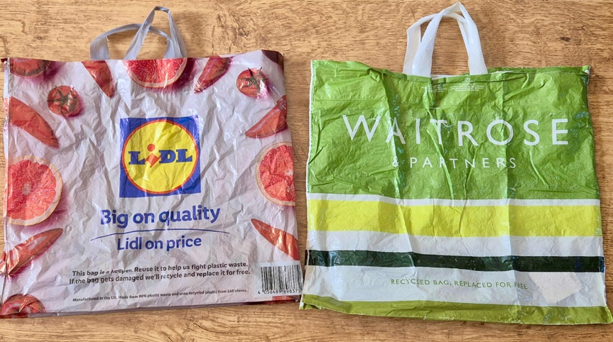

If you are considering donating either food or money to us, please do have a look at our donations page https://wallingfordfoodbank.org.uk/donate/
It has all the information you need to help us help local people in need. We still have lots of pasta, baked beans and tinned fish so please avoid donating those! Check the BanktheFood app for up-to-date requests for urgently needed items.

It is wonderful still to have your support.

Thank you all so much

Alice Penney

